**Experiment No. 1.3**

**Student Name:** Gaurav Kumar  **UID:** 22MCC20177

**Branch:** MCA **–** CCD **Section/Group:** MCD-1/ Grp A

**Semester:** III **Date of Performance:** 15th Oct 23 **Subject Name:** CONTAINERIZATION **Subject Code:** 22CAH-742

WITH DOCKER

**1. Aim/Overview of the practical:**

1. Deploy Docker images as stateless containers**.**

**2. Code for practical:**

1. Open Windows PowerShell as Administrator and login into it by running the command **docker login -u “username”.**

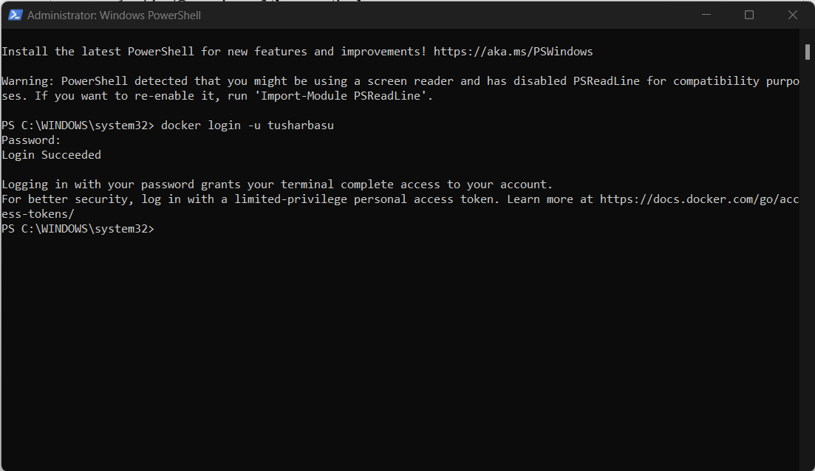

1. Use docker run command to run nginx.

**docker run --name nginx-webserver -p 80:80 nginx**

**Output:**

